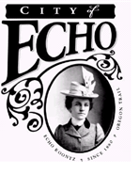

THE COMMON COUNCIL OF THE CITY OF ECHO WILL HOLD A WORK SESSION MEETING AT 6:00 PM, TUESDAY, APRIL 29th, 2021 AT CITY HALL UPSTAIRS IN THE COMMUNITY ROOM 20 S BONANZA, ECHO.

AGENDA

- Open
- City Water System Master Plan update with Anderson/Perry
- Close

If you would like to attend the council meeting and need special accommodations, please make requests at least 48 hours prior to the meeting. Contact the City Hall at 376-8411 to make arrangements.
____________________________________________________________________________________

